Bowel Prep Instructions – MiraLAX®

Your doctor will be using a small camera to look inside your colon (bowel). To see the inside, you will need to clean out your colon.

Please use this checklist to make sure you are ready for the procedure. If you do not, your procedure may be cancelled or must be repeated. If you have questions, please contact your doctor's office.

Date of my colonoscopy: *** Arrival time: ***
Location of my colonoscopy: Olathe Medical Center, Dr Building #2 Suite #101
20805 W 151st St, Olathe, Ks 66061
One week before my colonoscopy:

I will buy the following:
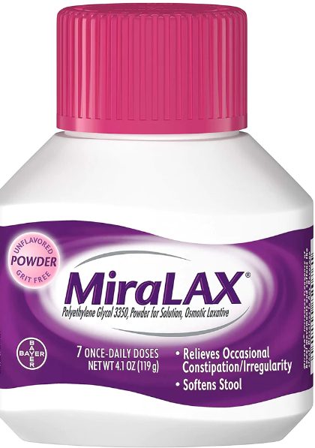  MiraLAX® 8.3 oz. powder (or generic polyethylene glycol 3350).  You may need more than 1 bottle of MiraLAX® (if you have fewer than 3 stools a week, take narcotics, or have a history of poor prep please contact doctor’s office). | 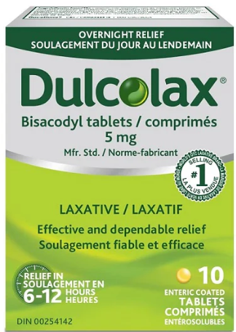  Dulcolax® (bisacodyl) laxative tablets (not a stool softener and not a suppository).  I need 2 tablets.
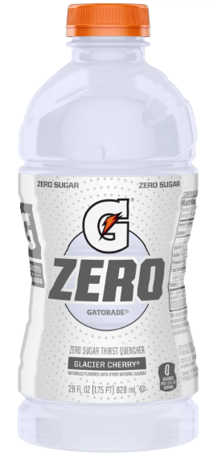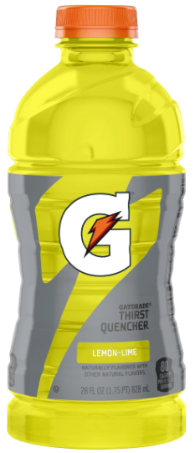  Two 28-32 oz. bottles of clear, yellow, orange or green Gatorade®. Do not use red or purple. If I have diabetes, it is ok to get a low-calorie drink. | Clear liquids.  These are liquids that I can see through.  Examples are water, clear broth, bouillon, clear sodas (7-Up®, Sprite®, ginger ale), apple juice, black coffee, tea, popsicles (no red or purple), Jell-O (no red or purple) and pulp free lemonade.

- I need to tell my doctor about ALL the medicines I take.

Blood thinners such as Coumadin® (warfarin), Plavix® (clopidogrel), Xarelto® (rivaroxaban), Eliquis® (apixaban), Pletal® (cilostazol), Brillinta® (ticagrelor), Aggrenox® (ASA/dipyridamole), Effient® (prasugrel) or Savaysa® (edoxaban).
- Contact your prescribing physician 1 week prior to your colonoscopy to ensure you can stop your medication.
** Baby Aspirin (81mg) and full-strength Aspirin 325 mg is ok.**

Diabetes medicines may need to be adjusted. I will tell my primary care doctor that I am having a colonoscopy so they can change my doses, if needed.

GLP-1 medications such as Trulicity (dulaglutice), Bydureon, Ozempic (semaglutide), Wegovy (semaglutide), Mounjaro (terzepatide), Byetta (exenatide), Victoza (liraglutide), Saxenda (liraglutide), Adlyxin (lixisenatide), Rybelsus (semaglutide), Zepbound (tirzepatide). If taking daily hold the day of procedure, if taken weekly hold 1 week prior to procedure.

Phentermine will need to be held a minimum of 14 days prior to the procedure.

Blood pressure medicines will continue as directed by my doctor. A nurse will tell me which medicines I can take on the day of the procedure.

Vitamins and dietary supplements will need to be stopped 5 days before my colonoscopy. This includes herbal supplements and fish oil.

□ I need to arrange an adult to drive me to and from the procedure.
I will be given medicines to make me sleepy and will not be able to drive or operate machines after the procedure. I will not be allowed to take a bus, taxi, Uber/Lyft, or walk home unless I am with an adult. My procedure will be cancelled if an adult is not with me.

5 days before the procedure:

    - Stop taking iron pills, herbal medicines, supplements, and vitamins.

    - Stop eating nuts, seeds, popcorn, and corn.

2 days before the procedure:

- Pour out or drink a little Gatorade® from each bottle to make room. Mix 7 doses of MiraLAX® (½ of the 8 oz. bottle) in each 28-32 oz. bottle of Gatorade®. You will use 1 bottle of MiraLAX® between the two bottles of Gatorade®.

Shake well and put in refrigerator for best taste.

1 day before the procedure:

- Only drink clear liquids. I cannot eat any solid food or dairy products.

- At noon, take 2 Dulcolax® tablets (5 mg each). Drink at least four 8 oz. glasses of clear liquids.

- At 5pm, drink the first 28-32 oz. bottle of Gatorade®/MiraLAX®. Drink 8 oz. every 15 minutes until gone. Stay near a bathroom.
  - If I start to feel sick to my stomach, I will try drinking the mix slowly. Walking around may help.

- Continue to drink at least four 8 oz. glasses of clear liquids. No alcohol or marijuana. If I chew tobacco, I will stop using 8 hours before my procedure.

Morning of the procedure:
- Take my normal morning medications.

- 5 hours prior to your procedure, drink the second 28-32 oz. bottle of Gatorade®/MiraLAX®. Drink 8 oz. every 15 minutes until gone. Stay near a bathroom.

- The last bowel movement before my arrival should be like water.
- No fluids, including water, 2 hours prior to the procedure.

If you have any questions, please call our office at 913-355-3896.

