 **Stella G. Quiason,MD Ashok Attaluri, MD**

**Balaji Datti, MD**

**Chethana Kanaparthi, MD**

**Jennifer Fowler, NP**

**Ashley Alonso, NP**

**Gastroenterology & Liver Diseases**

Phone: 913-393-9898 Fax: 913-393-9893

***Video Capsule Endoscopy***

**When am I scheduled?**

Procedure Date:__________at 7:15 am. Please check-in at Doctors Building 2 Suite 101 at 7:00am.

***The transmitter is due back at the GI Lab by 3:00pm.***

**This is important information that may result in your procedure being rescheduled if not followed:**

**7 DAYS PRIOR:**

 PLEASE **STOP** TAKING **IRON** SUPPLEMENTS 7 DAYS PRIOR TO THE VIDEO

CAPSULE ENDOSCOPY.

 Pick up 1 bottle of Miralax 4.1oz 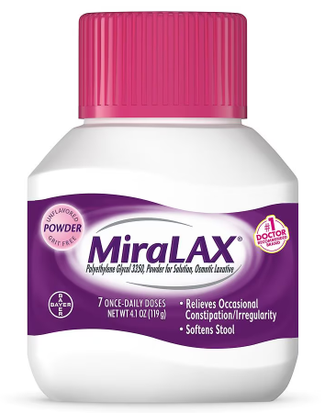 and one 28-32oz bottle of Gatorade for the prep at the pharmacy/store. No RED or PURPLE.

 Call the customer service number on your insurance card to check with your insurance company to see what your coverage is going to be. This will minimize financial surprises as each insurance company and plan pays for this procedure differently.

*If your insurance does not approve this procedure someone will reach out to reschedule.*

**THE DAY BEFORE:**

 You may have a light breakfast (toast, small bowl of oatmeal-**no milk or milk**

**products**). The *rest of the day* you are to be on a LIQUID DIET. NO SOLID FOODS.

**Liquids that are ok include**: Cola, diet Cola, juice (apple, white grape-juices with no pulp) coffee (no cream), tea, broth, jello, and popsicles (**no red- or purple-colored liquids**).

**5:00 PM** : Pour out/drink a small amount of the Gatorade, THEN add the Miralax to the Gatorade bottle. SHAKE WELL. Drink 8 oz every 10-15 minutes until finished.

**Please remember to remain close to a bathroom during this time. Every patient has a different response to taking the prep medication and urgency to have a bowel movement may be immediate or delayed. Please remain on all-clear liquid diet. **

**THE DAY OF THE PROCEDURE:**

 The capsule endoscopy test will last 8-9 hours. **Contact the office immediately if you experience any abdominal pain, nausea or vomiting during the procedure**.

 Please wear loose-fitting two-piece clothing. Do not apply any lotions or body powders to your abdomen.

 On the day of the procedure you are to **not take any morning medication until 2 hours after you swallow the capsule**. This will make sure that the view of the capsule is not obscured by anymedication you may take.

 **NO SOLID FOODS AFTER MIDNIGHT**. **YOU MAY HAVE LIQUIDS ONLY UNTIL 2 HOURS PRIOR TO THE PROCEDURE.**

 You may drink colorless liquids starting 2 hours after swallowing the capsule**.**

 You **may have a light snack 4 hours after ingestion**. No fresh fruits or vegetables and continue to stay away from colored liquids. Soups, sandwiches are ok for you to have.

 Check the blue flashing Data recorder light every 15 minutes to make sure it is blinking twice per second. **If it stops blinking or changes colors, please note the time and call the office**.

 Use the supplied capsule endoscopy event form to note the time of any event such as eating,

drinking or a change in your activity. Return the completed Event Form when you return the equipment.

 **Please avoid strong magnetic fields** such as MRI devices or HAM radios until you pass the capsule in a bowel movement.

 **DO NOT DISCONNECT the equipment or remove the belt at any time** during the procedure. Avoid sudden movements and banging of the data recorder and avoid direct exposure to bright sunlight.